**Write a program non-recursive and recursive program to calculate Fibonacci numbers and analyze their time and space complexity.**

CODE :

# Write a program to print fibonacci series upto n terms in python num = 10 n1, n2 = 0, 1

print("Fibonacci Series:", n1, n2, end=" ") for i in range(2, num):

n3 = n1 + n2 n1 = n2 n2 = n3 print(n3, end=" ")

print()

# Python program to print Fibonacci Series def fibonacciSeries(i): if i <= 1:

return i

else:

return (fibonacciSeries(i - 1) + fibonacciSeries(i - 2))

num=10 if num <=0:

print("Please enter a Positive Number")

else:

print("Fibonacci Series:", end=" ")

for i in range(num):

print(fibonacciSeries(i), end=" ")

OUTPUT :

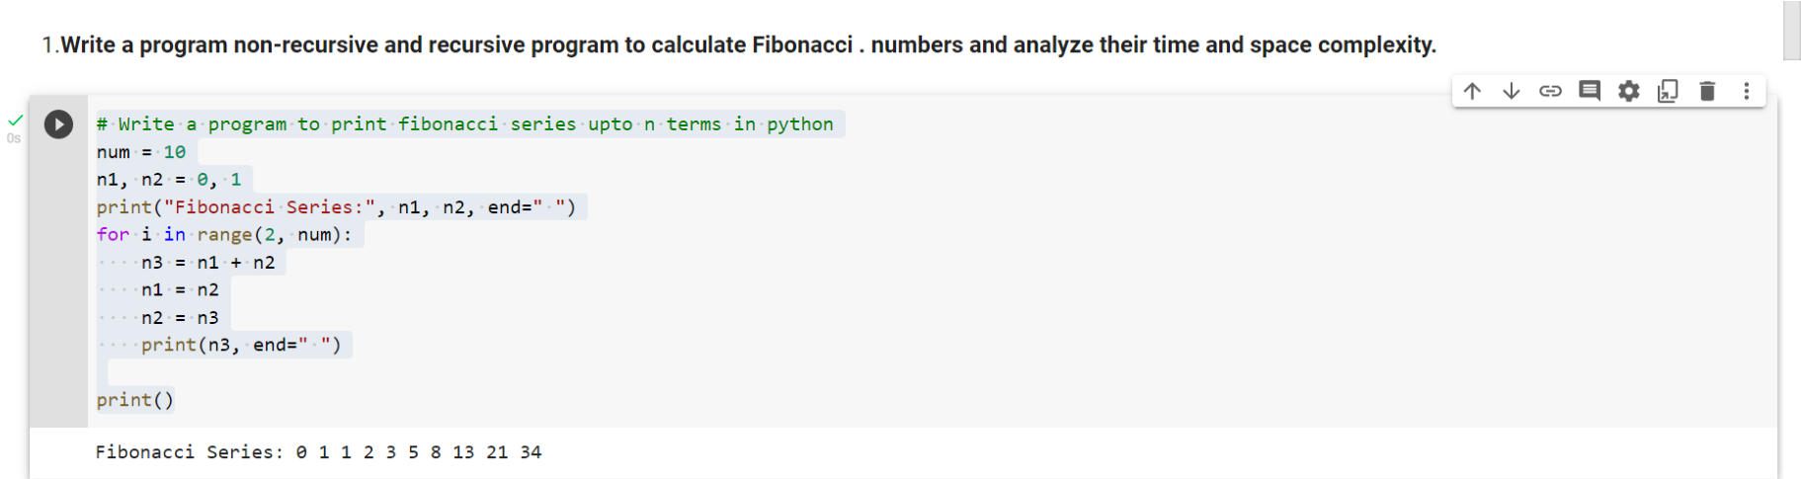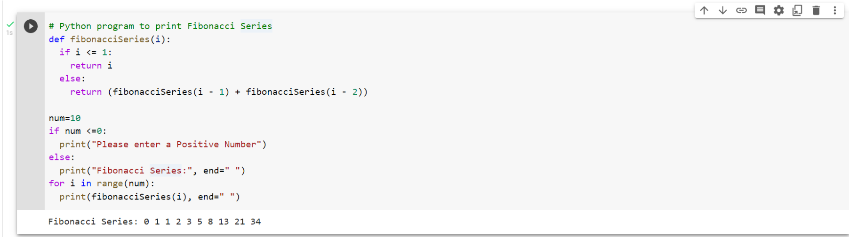

**Write a program to implement Huffman Encoding using a greedy strategy.**

CODE:

# Huffman Coding in python

string = 'BCAADDDCCACACAC'

# Creating tree nodes class NodeTree(object):

def __init__(self, left=None, right=None): self.left = left self.right = right

def children(self): return (self.left, self.right)

def nodes(self): return (self.left, self.right)

def __str__(self): return '%s_%s' % (self.left, self.right)

# Main function implementing huffman coding def huffman_code_tree(node, left=True, binString=''):

if type(node) is str:

return {node: binString} (l, r) = node.children() d = dict()

d.update(huffman_code_tree(l, True, binString + '0'))

d.update(huffman_code_tree(r, False, binString + '1')) return d

# Calculating frequency freq = {} for c in string:

if c in freq:

freq[c] += 1 else:

freq[c] = 1

freq = sorted(freq.items(), key=lambda x: x[1], reverse=True)

nodes = freq

while len(nodes) > 1:

(key1, c1) = nodes[-1] (key2, c2) = nodes[-2] nodes = nodes[:-2] node = NodeTree(key1, key2) nodes.append((node, c1 + c2))

nodes = sorted(nodes, key=lambda x: x[1], reverse=True)

huffmanCode = huffman_code_tree(nodes[0][0])

print(' Char | Huffman code ') print('----------------------') for (char, frequency) in freq: print(' %-4r |%12s' % (char, huffmanCode[char]))

OUTPUT:

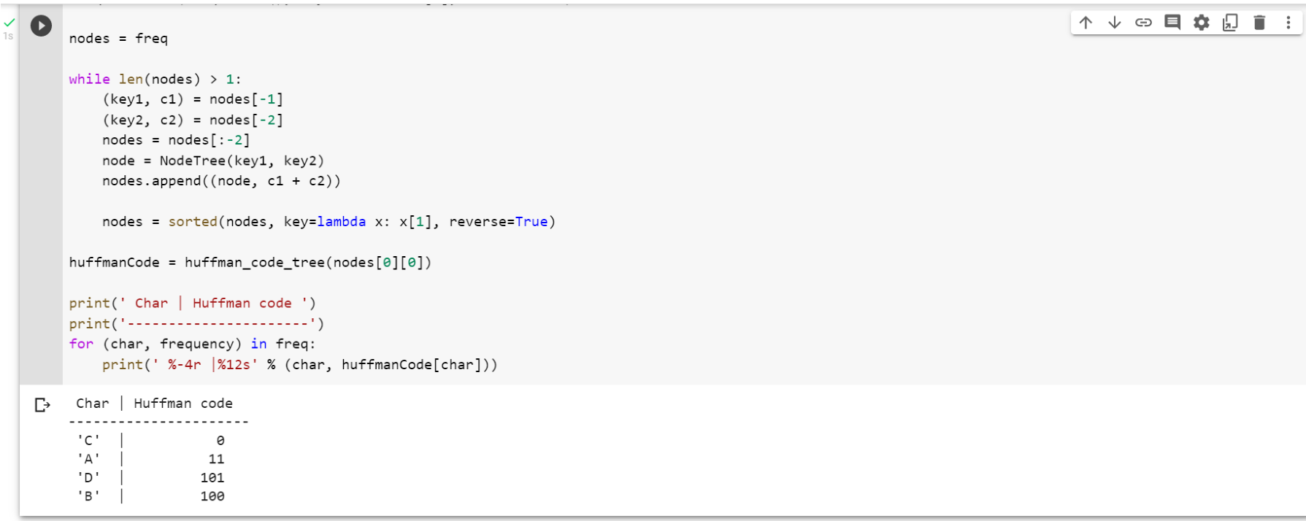

**Write a program to solve a fractional Knapsack problem using a greedy method.**

CODE:

# Structure for an item which stores weight and corresponding value of Item class Item: def __init__(self, value, weight):

self.value = value self.weight = weight

# Main greedy function to solve problem def fractionalKnapsack(W, arr):

# sorting Item on basis of ratio arr.sort(key=lambda x: (x.value/x.weight), reverse=True) finalvalue = 0.0 # Result(value in Knapsack) for item in arr: # Looping through all Items

# If adding Item won't overflow, add it completely if item.weight <= W: W -= item.weight finalvalue += item.value

else: finalvalue += item.value * W / item.weight break

return finalvalue # Returning final value

# Driver's Code if __name__ == "__main__": W = 50 # Weight of Knapsack

arr = [Item(60, 10), Item(100, 20), Item(120, 30)] max_val = fractionalKnapsack(W, arr) # Function call print ('Maximum value we can obtain = {}'.format(max_val))

OUTPUT:

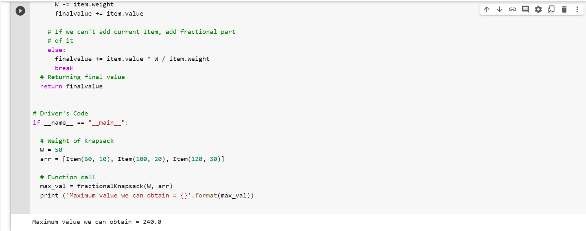

**Write a program to solve a 0-1 Knapsack problem using dynamic programming or branch and bound strategy.**

CODE:

#DYNAMIC PROGRAMMING

# Returns the maximum value that can be stored by the bag def knapSack(W, wt, val, n):

K = [[0 for x in range(W + 1)] for x in range(n + 1)]

#Table in bottom up manner for i in range(n + 1):

for w in range(W + 1):

if i == 0 or w == 0:

K[i][w] = 0 elif wt[i-1] <= w:

K[i][w] = max(val[i-1] + K[i-1][w-wt[i-1]], K[i-1][w]) else:

K[i][w] = K[i-1][w] return K[n][W] #Main

val = [50,100,150,200] wt = [8,16,32,40]

W = 64

n = len(val)

print(knapSack(W, wt, val, n))

OUTPUT:

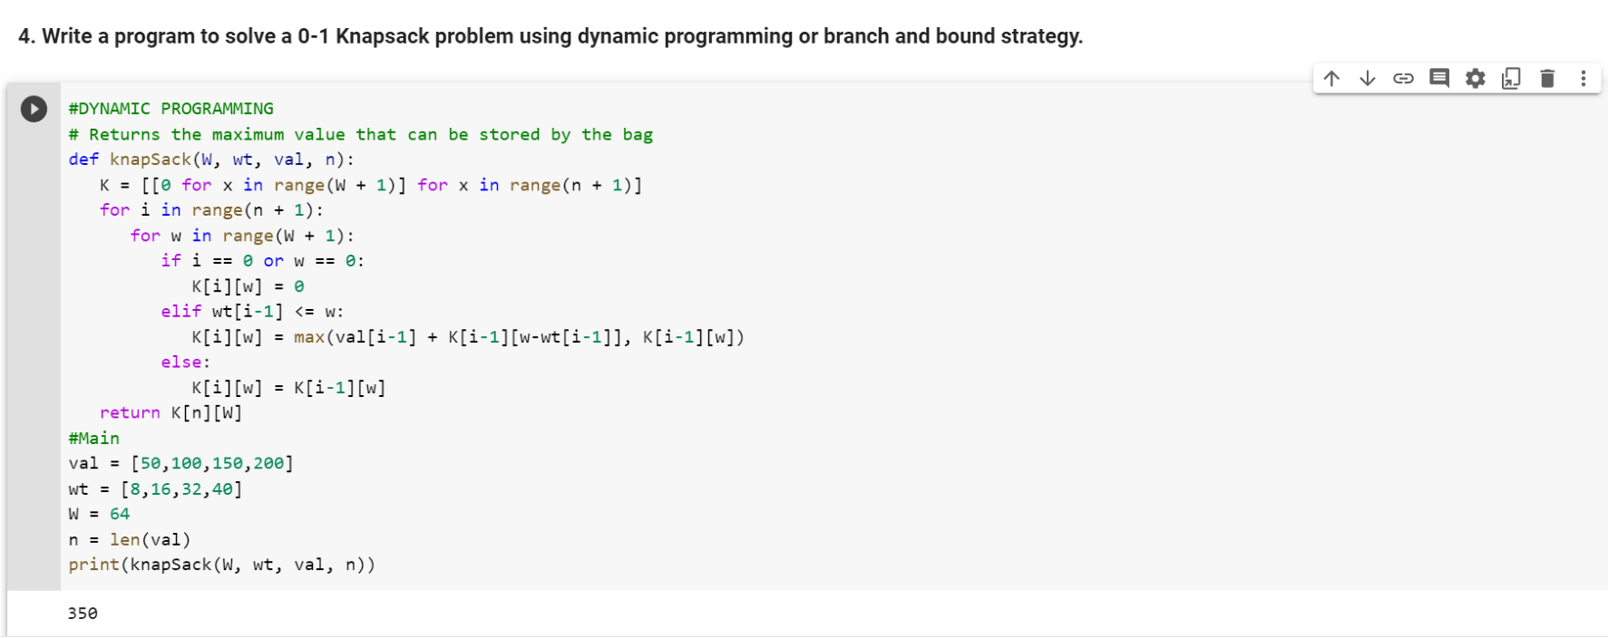

**Design n-Queens matrix having first Queen placed. Use backtracking to place remaining Queens to generate the final n-queen‘s matrix.**

CODE:

# Python3 program to solve N Queen # Problem using backtracking global N

N = 4

def printSolution(board): for i in range(N):

for j in range(N):

print(board[i][j], end = " ")

print(

def isSafe(board, row, col): # attacking queens

# Check this row on left side for i in range(col):

if board[row][i] == 1:

# return False

# Check upper diagonal on left side for i, j in zip(range(row, -1, -1),

range(col, -1, -1)):

if board[i][j] == 1:

# return False

# Check lower diagonal on left side for i, j in zip(range(row, N, 1),range(col, -1, -1)):

if board[i][j] == 1:

# return False return True

def solveNQUtil(board, col):

# base case: If all queens are placed

# then return true if col >= N:

# return True

# Consider this column and try placing # this queen in all rows one by one for i in range(N):

if isSafe(board, i, col):

# Place this queen in board[i][col]

board[i][col] = 1

# recur to place rest of the queens if solveNQUtil(board, col + 1) == True: return True

# If placing queen in board[i][col

# doesn't lead to a solution, then # queen from board[i][col] board[i][col] = 0

# if the queen can not be placed in any row in # this column col then return false return False

def solveNQ():

board = [ [0, 0, 0, 0],

[0, 0, 0, 0],

[0, 0, 0, 0],

[0, 0, 0, 0] ]

if solveNQUtil(board, 0) == False: print ("Solution does not exist") return False

printSolution(board) return True

# Driver Code solveNQ()

OUTPUT:

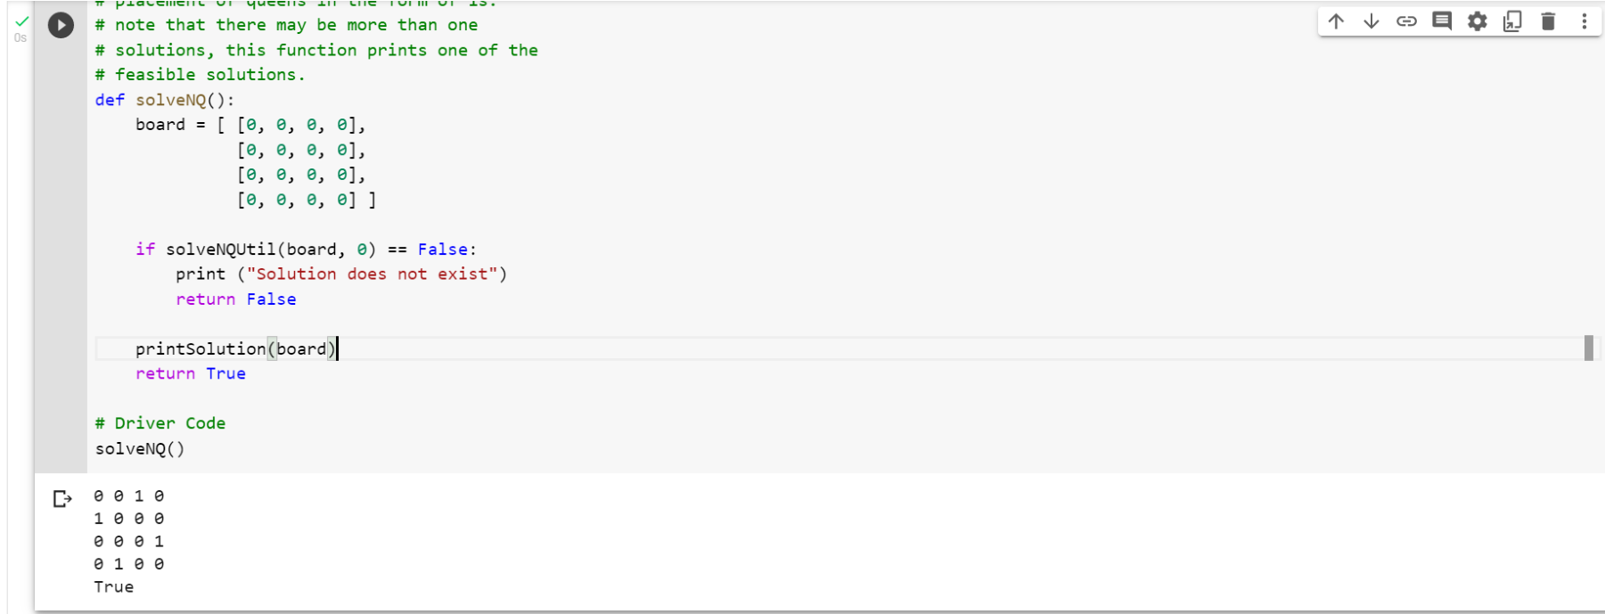

**MINI PROJECT:**

**Implement the Naive String Matching Algorithm and Rabin-Karp Algorithm for string Matching. Observe difference in working of both algorithms for the same input.**

CODE:

**# Python program for Naive Pattern**

**# Searching algorithm def search(pat, txt):**

**M = len(pat) N = len(txt) for i in range(N - M + 1): # A loop to slide pat[] one by one */ j = 0**

**# For current index i, check # for pattern match */ while(j < M):**

**if (txt[i + j] != pat[j]):**

**break**

**j += 1**

**if (j == M):**

**print("Pattern found at index ", i)**

**# Driver's Code if __name__ == '__main__':**

**txt = "GEEKS FOR GEEKS" pat = "GEEK"**

**# Function call search(pat, txt)**

OUTPUT :

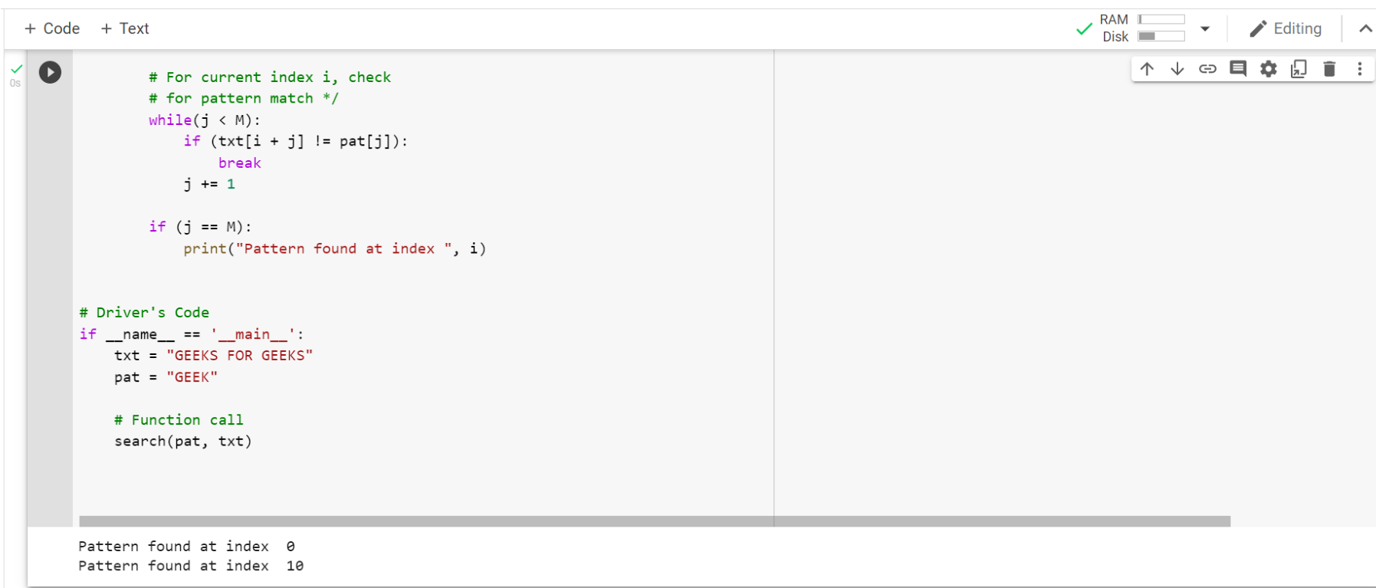

CODE :

**# d is the number of characters in the input alphabet d = 256**

**# pat -> pattern**

**# txt -> text # q -> A prime number**

**def search(pat, txt, q):**

**M = len(pat) N = len(txt) i = 0 j = 0 p = 0 # hash value for pattern t = 0 # hash value for txt h = 1**

**# The value of h would be "pow(d, M-1)%q" for i in range(M-1):**

**h = (h*d) % q**

**# Calculate the hash value of pattern and first window**

**# of text for i in range(M):**

**p = (d*p + ord(pat[i])) % q t = (d*t + ord(txt[i])) % q**

**# Slide the pattern over text one by one for i in range(N-M+1):**

**# Check the hash values of current window of text and**

**# pattern if the hash values match then only check**

**# for characters one by one if p == t:**

**# Check for characters one by one for j in range(M):**

**if txt[i+j] != pat[j]:**

**break**

**else:**

**j += 1**

**# if p == t and pat[0...M-1] = txt[i, i+1, ...i+M-1] if j == M:**

**print("Pattern found at index " + str(i))**

**# Calculate hash value for next window of text: Remove**

**# leading digit, add trailing digit if i < N-M: t = (d*(t-ord(txt[i])*h) + ord(txt[i+M])) % q**

**# We might get negative values of t, converting it to**

**# positive if t < 0:**

**t = t+q**

**# Driver Code if __name__ == '__main__': txt = "GEEKS FOR GEEKS" pat = "GEEK"**

**# A prime number q = 101**

**# Function Call search(pat, txt, q)**

OUTPUT:

